PROJECT DEVELOPMENT PHASE

SPRINT 2

|  |  |
| --- | --- |
| Team ID | PNT2022TMID23716 |
| Project Name | Smart Fashion Recommender Application |

**Creating a chatbot to deal with the customers through the application:**

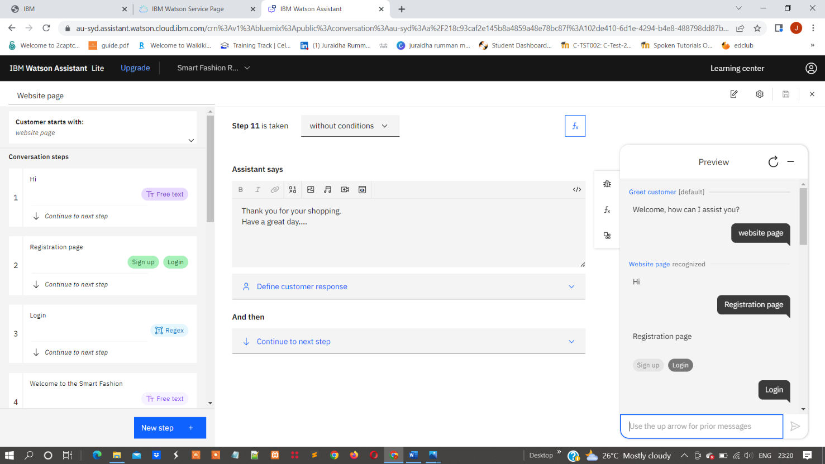

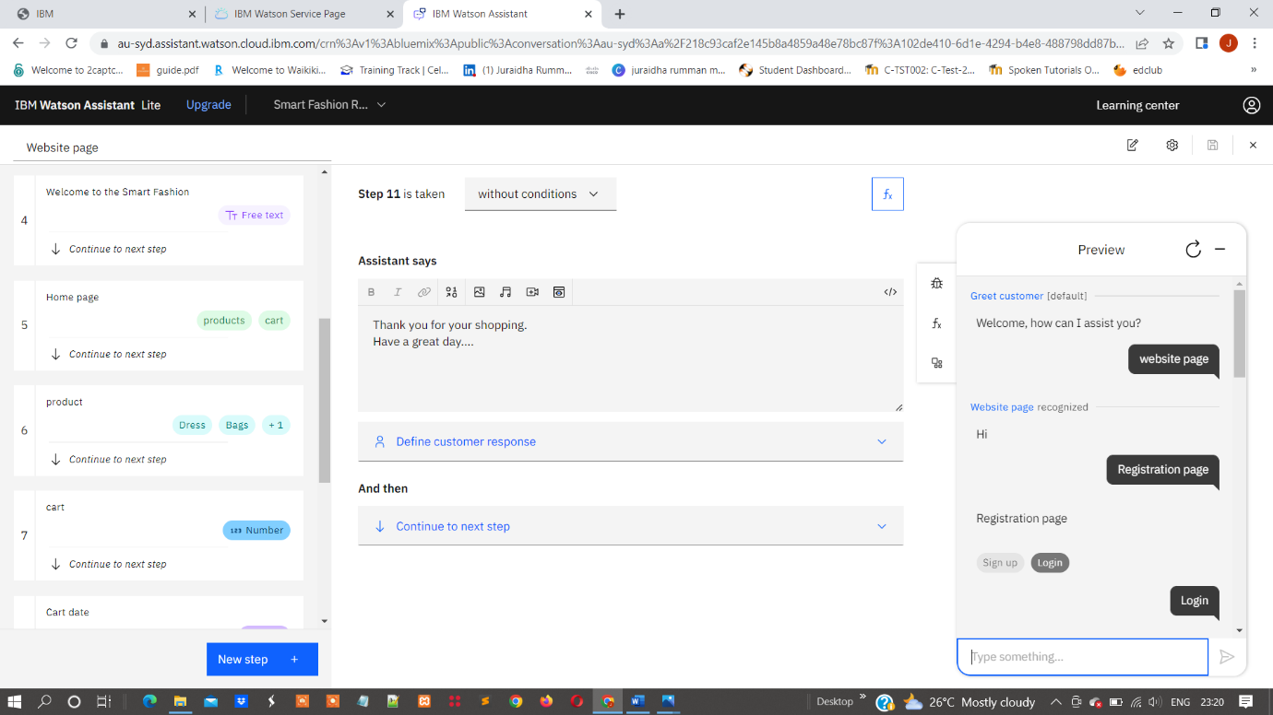

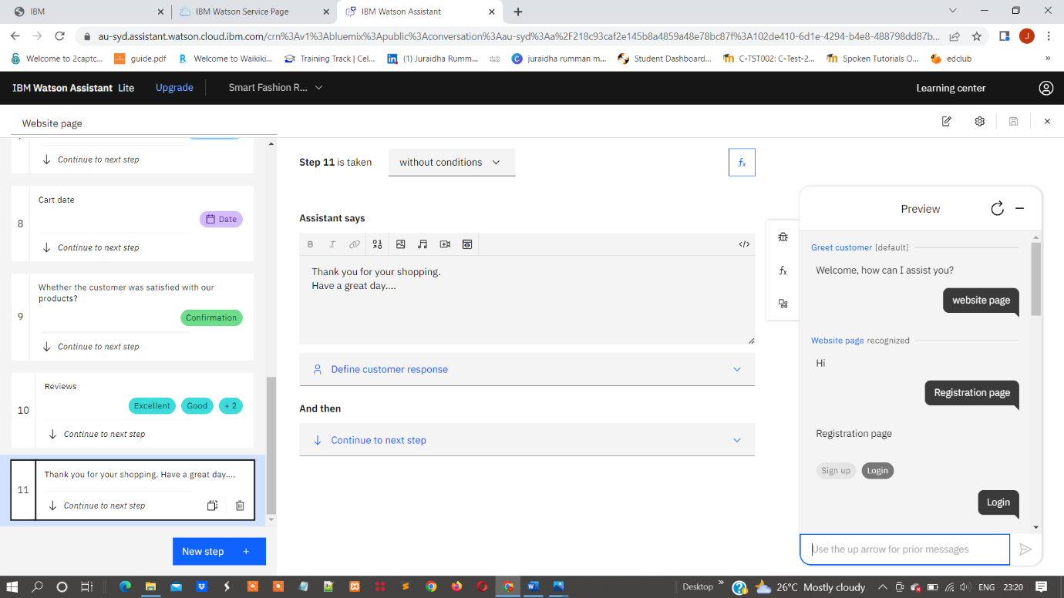

**WEB CHAT:**

The customer will chat through the web chat to clear their queries:

Right side the web chat will be shown:

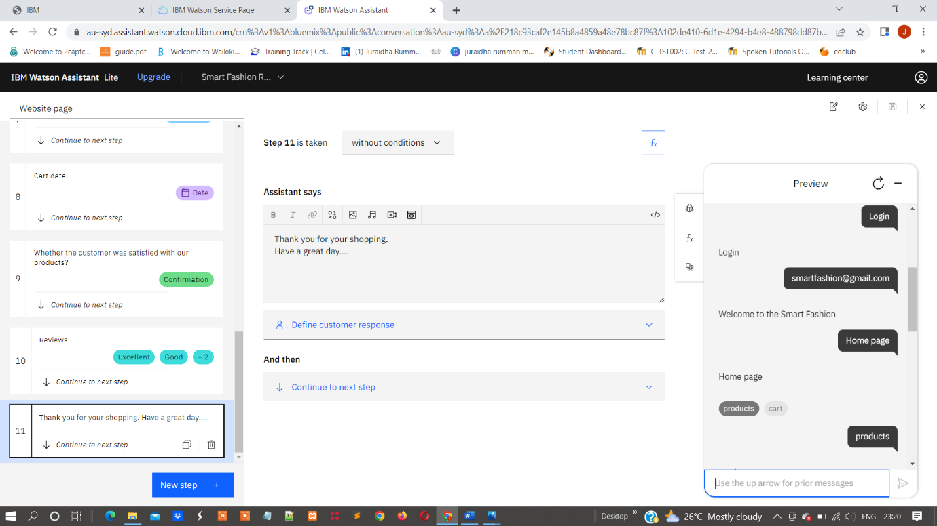

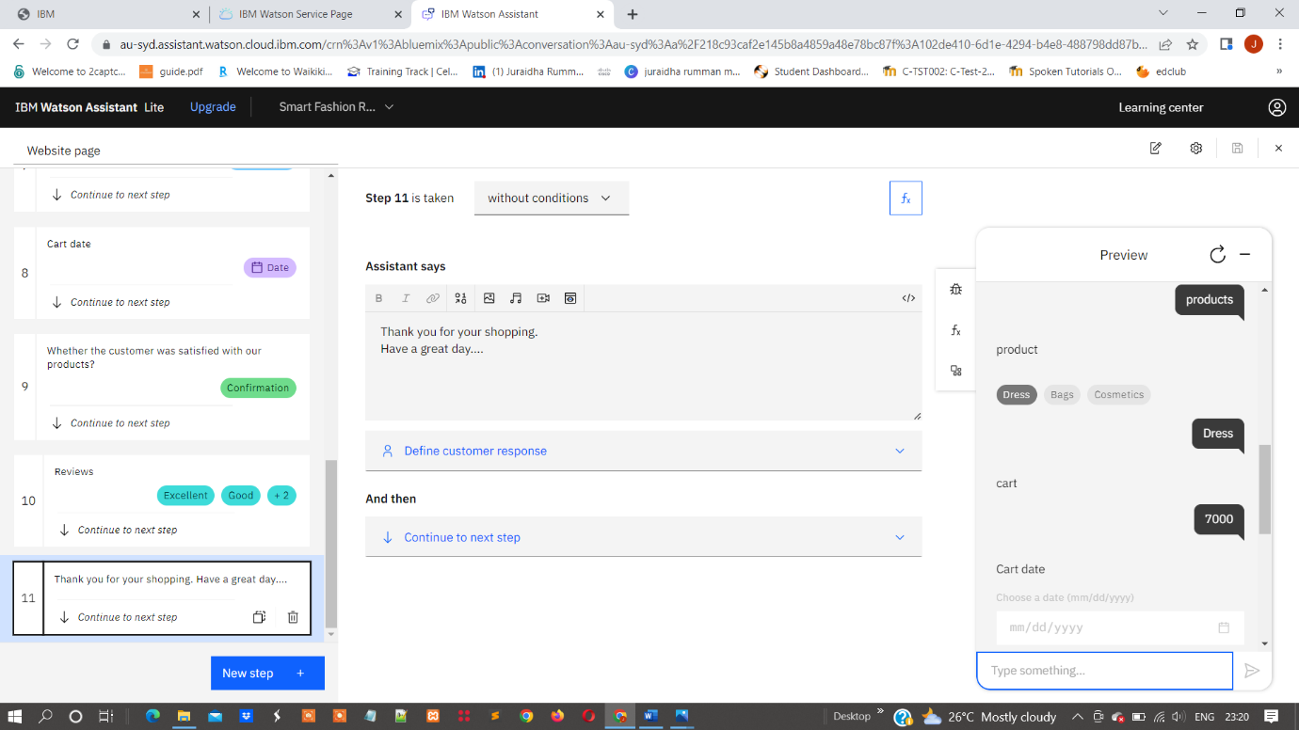

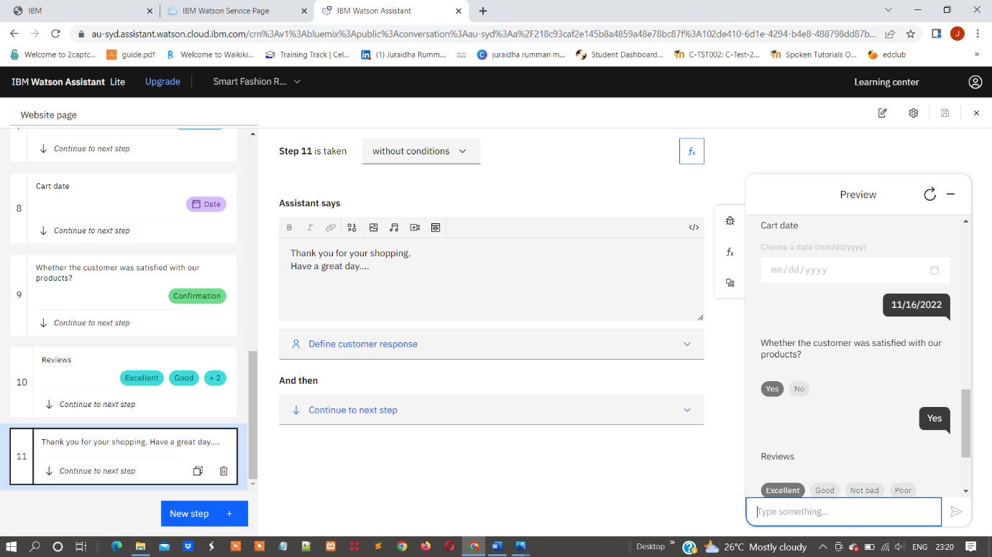

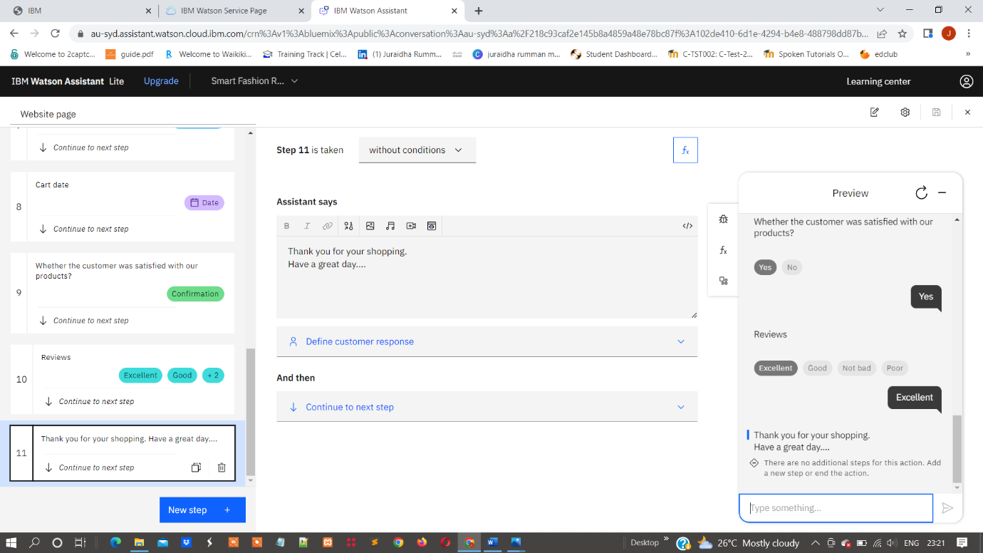

**Action page:**

**Smart Fashion Recommender Application – Website page:**

